

Faculty of Computer Science and Mathematics

Universiti Malaysia Terengganu

LAB REPORT

CSE3023 Web-Based Application Development

Name | Wai Pei Yuen
Matric No. | S74991
Semester | 2025/26-2
Lab Report | 4
Demonstrator | Ts. Dr. Wan Nural Jawahir Hj Wan Yussof

Task 1
Reflection
1. What have you learnt from this exercise?
I learned how to use JSP Scriptlets to perform arithmetic operations and handle condition if-else logic and JSP Expressions to output calculated results.

2. Explain three (3) types of JSP scripting elements.

1) JSP Scriptlets <% … %>
-used to contain Java Language statements, variable declarations or expressions

2) JSP Expression <%= … =>
-used to generate dynamic web content.

3) JSP Declaration <%! … %>
-used to define variables, constants, and methods for reusable logic within JSP pages.

Task 2
Reflection
1. What have you learnt from this exercise?
I learned how to JSP scripting to perform a currency conversion.

Task 3
Reflection
1. What have you learnt from this exercise?
I learned how to use the <jsp:include> to pull in content from another JSP page at runtime.

2. List TWO (2) other JSP Standard Action tags.
<jsp:forward> and <jsp:useBean>.

Task 4
Reflection
1. What have you learnt from this exercise?
I learned how to use <jsp:forward> to redirect a request from one JSP page to another JSP page on the server side.

2. List TWO (2) more JSP Standard Action Tag.
<jsp:setProperty> and <jsp:getProperty>.

Task 5
Reflection
1. What have you learnt from this exercise?
I learned how to implement complex business logic using JSP Scriptlets to calculate insurance premiums, NCD deduction and SST charges.

2. List all Java features you used in Java Scriptlet.

- Variable declaration and initialization: double price = 0;
- Conditional logic: if-else to determine insurance rates.
- Exception handling: try-catch blocks to manage non-numeric input.
- Arithmetic operators: *, -, + to calculate totals and taxes.

Exercise:
Source Code:
header.jsp
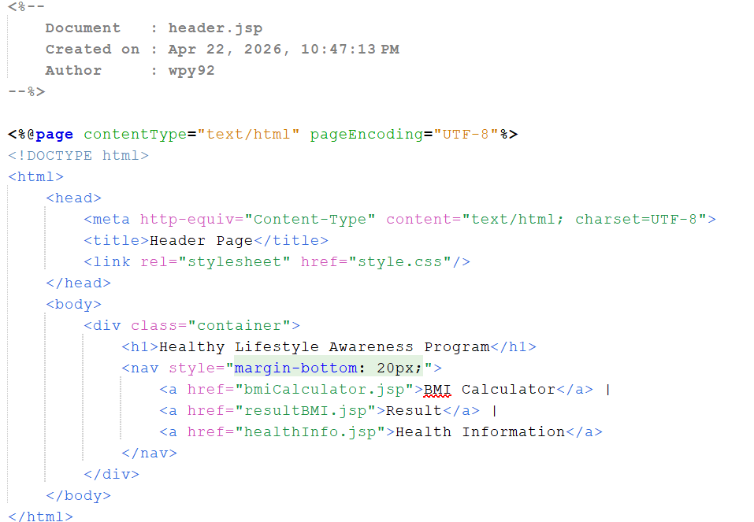

footer.jsp
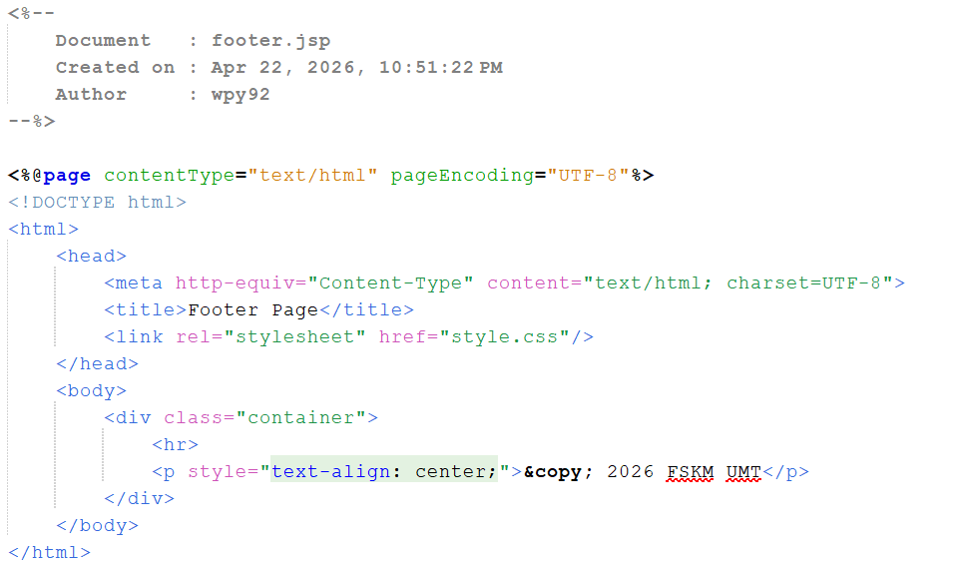

bmiCalculator.jsp
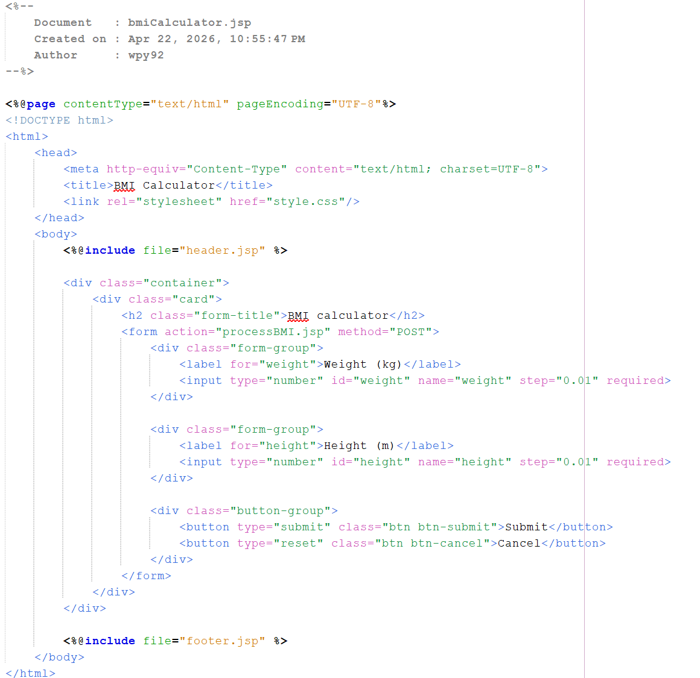

processBMI.jsp
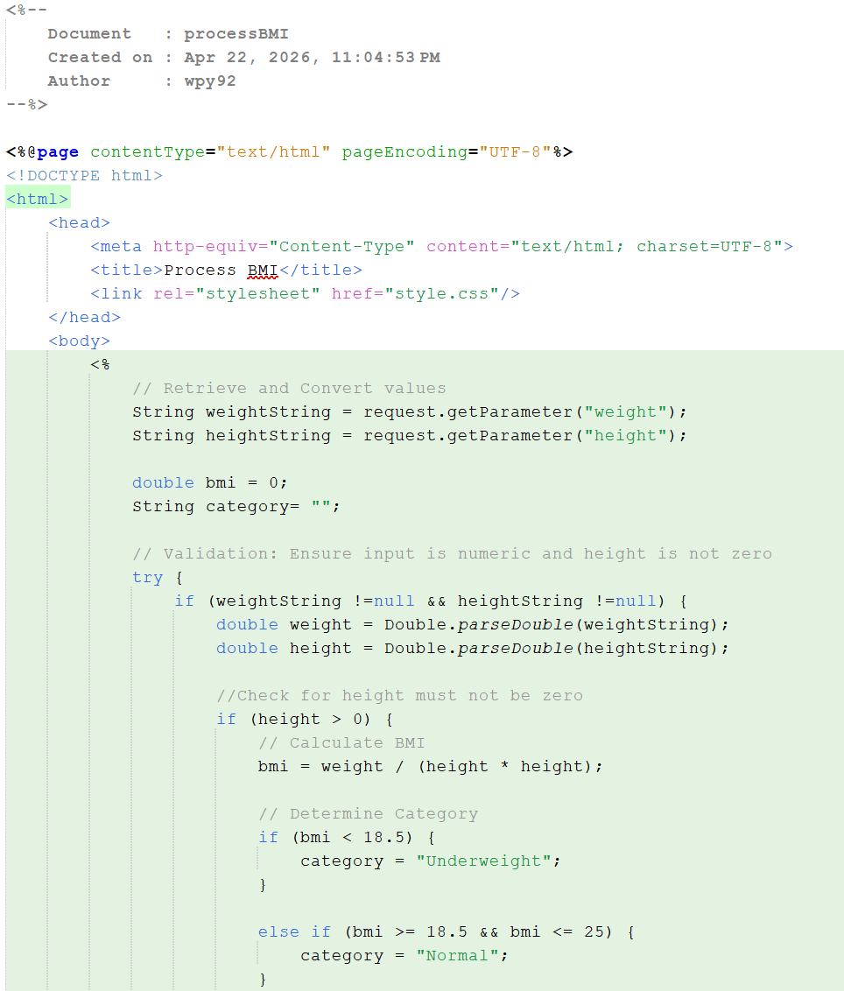
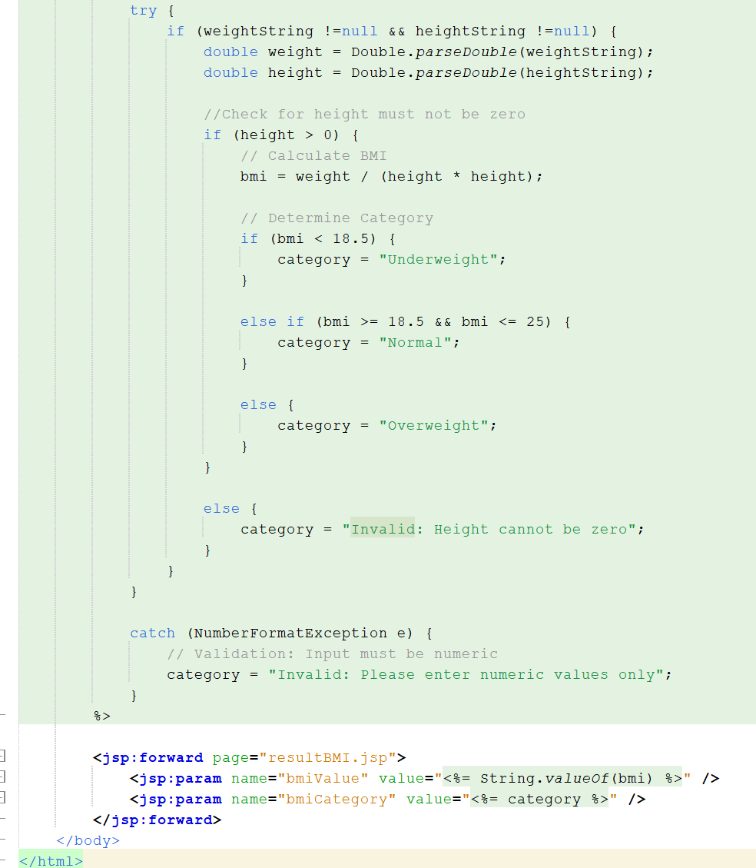

resultBMI.jsp
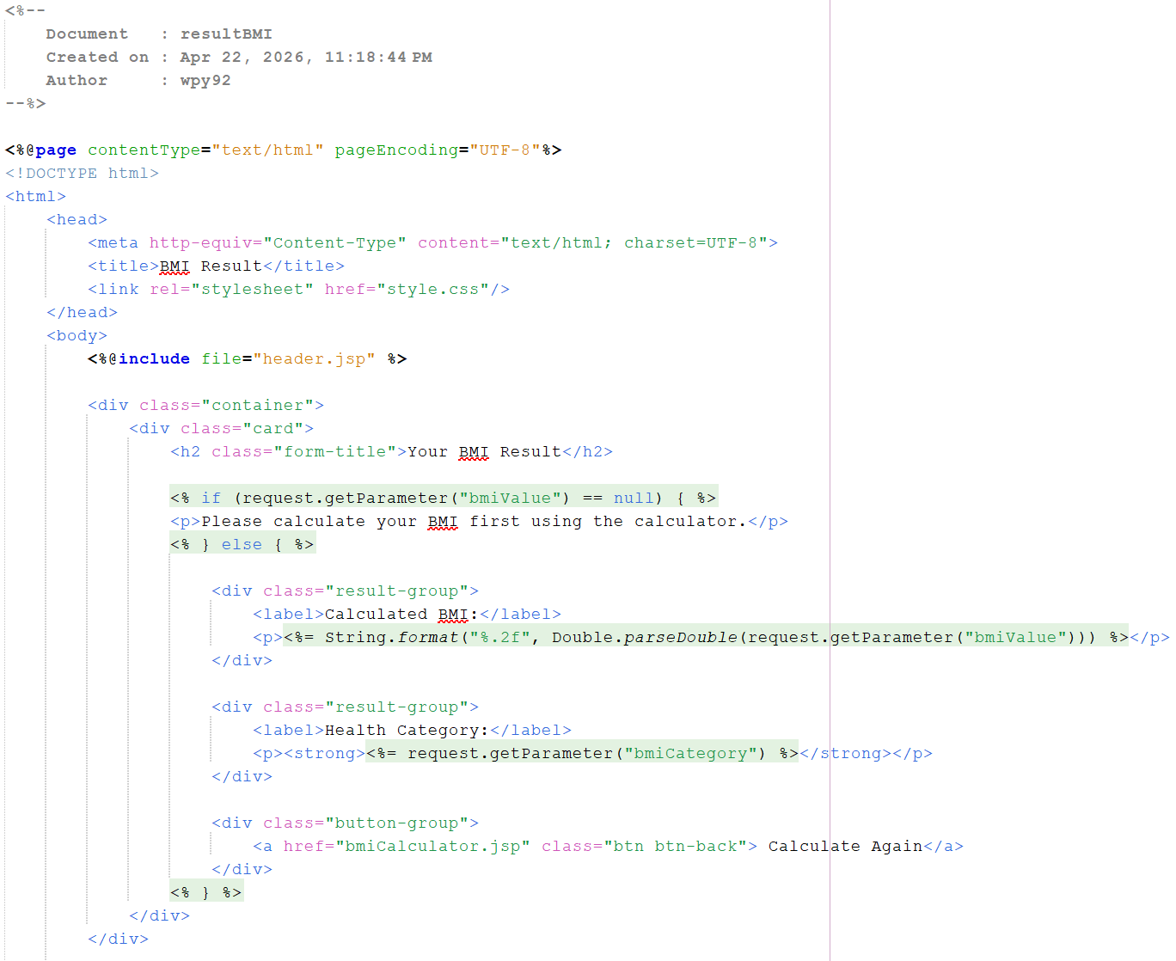
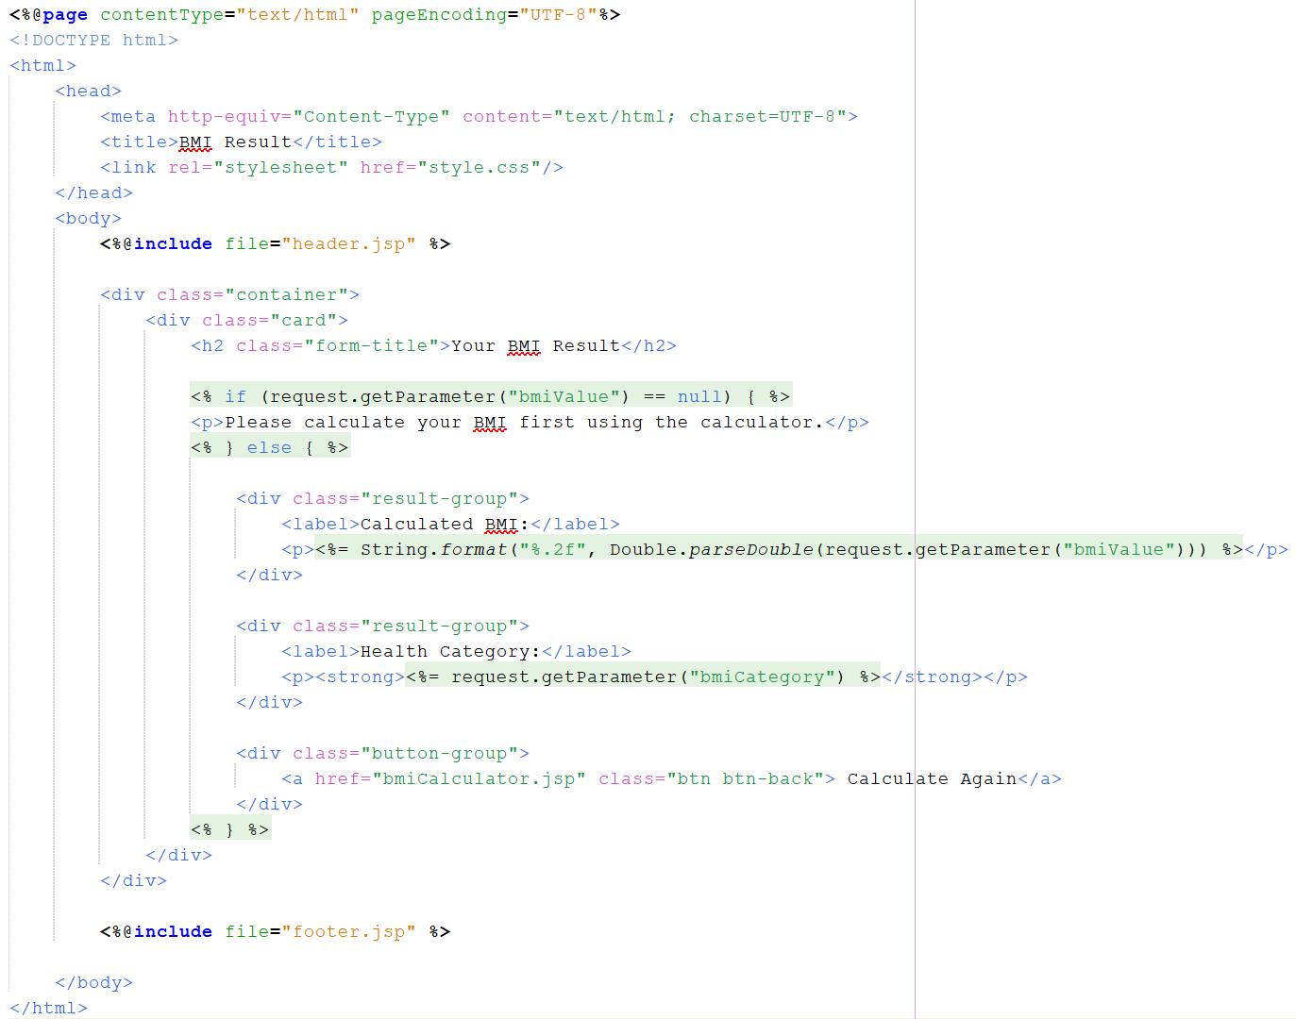

healthInfo.jsp

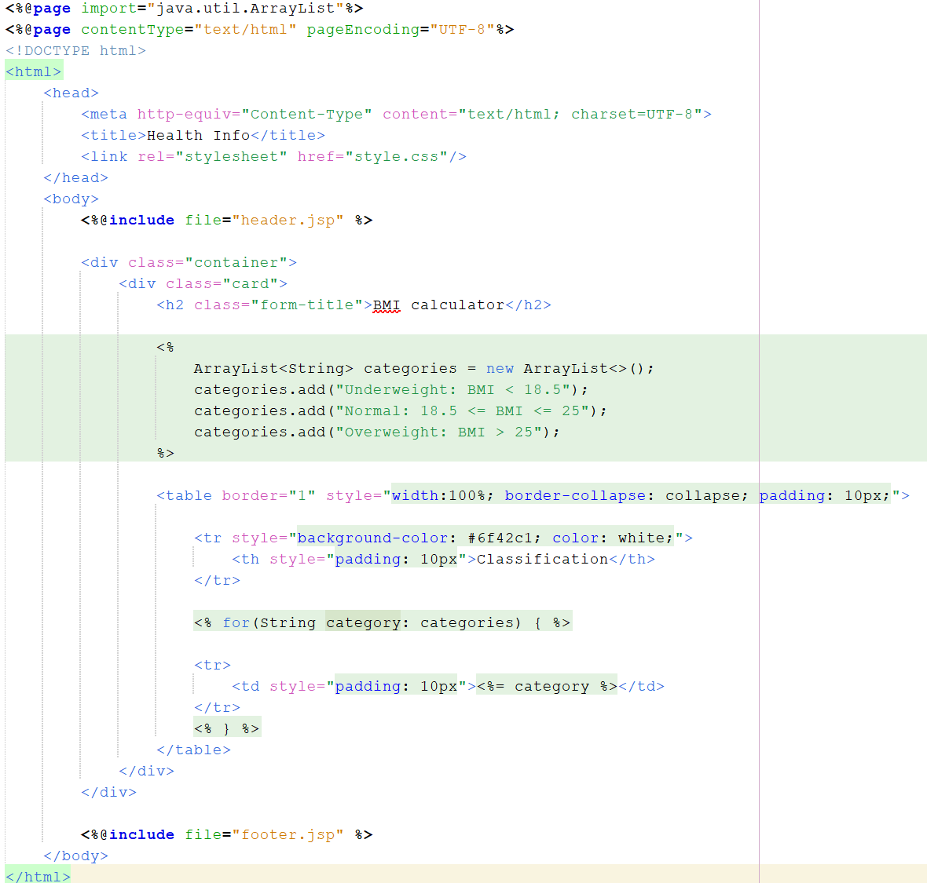

Output:
BMI Calculator
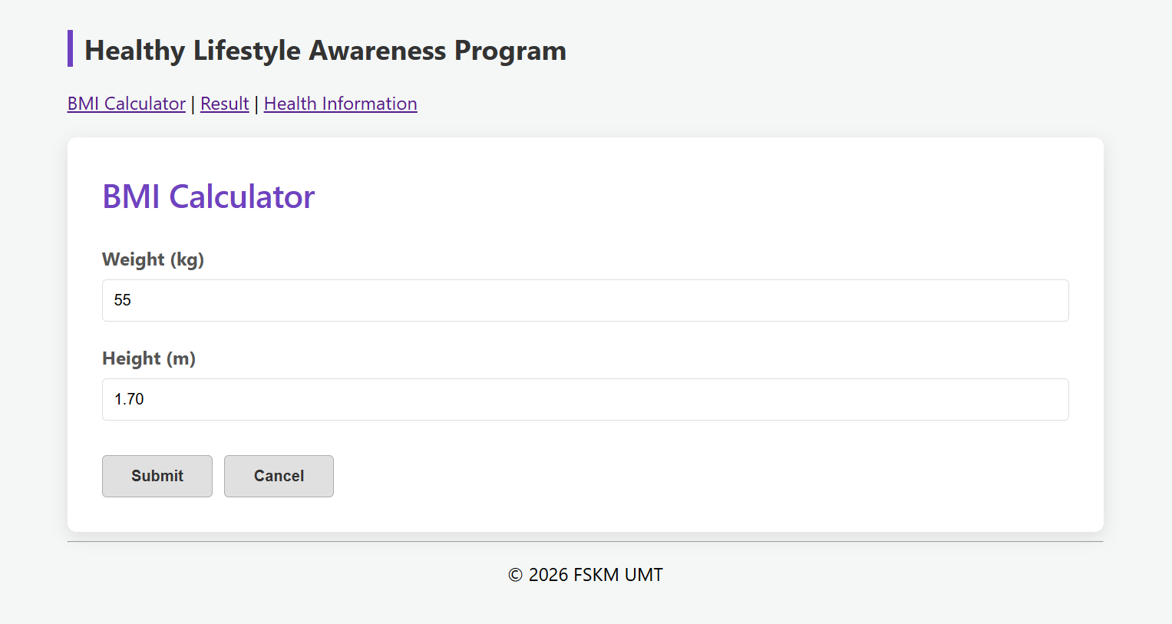

Result
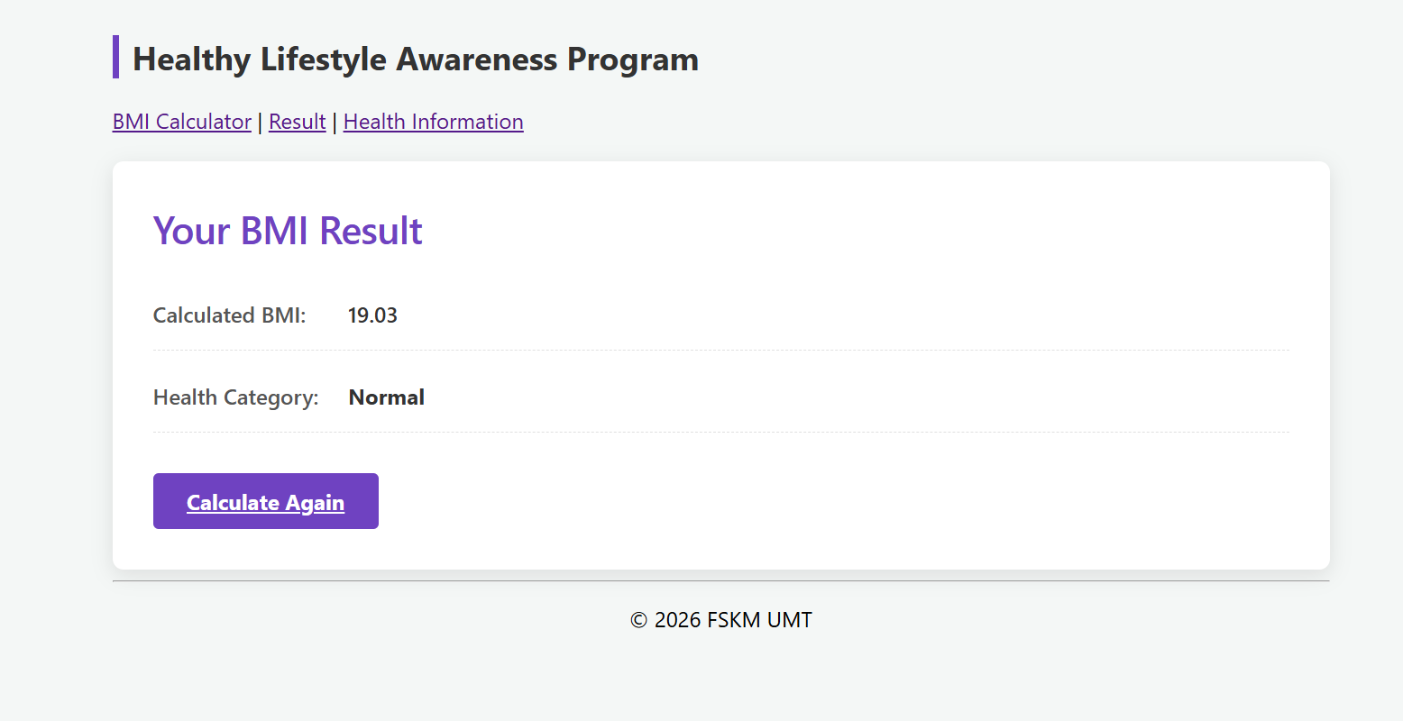

Health Information
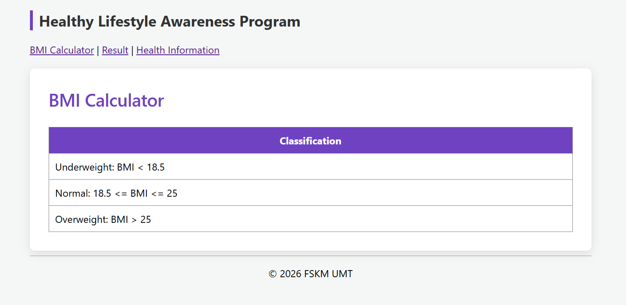

Validation: Input must be numeric and height cannot be zero.
